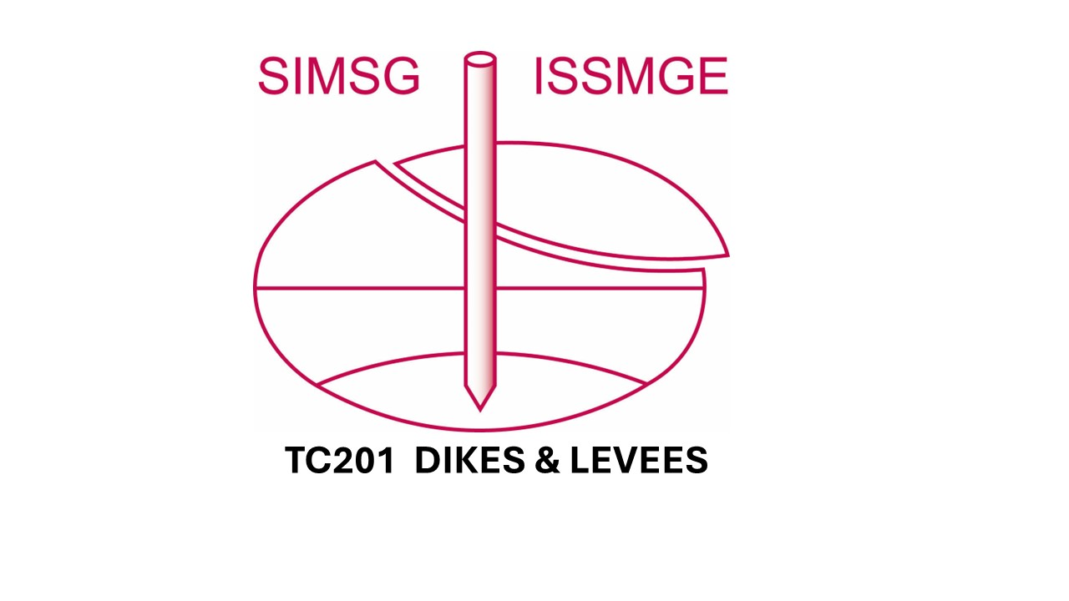
Past events supported by ISSMGE TC 106, TC 102, TC 201 and Soil Science Institute in Hungary
- 1st Unsaturated Soil Symposium- 1999. BME, Budapest, Hungary
- 2nd Unsaturated Soil Symposium- 2003. 2-5 of November. Ráckeve, Hungary
- 3rd Unsaturated Soil Symposium May 5, 2015. RISSAC, Budapest, Hungary
- 1st Middle European Conference on Landfill Technology 2008, at the Hungarian Academy of Science, Budapest, Hungary
- The Granular Matter Section JETC 2017, BME, Budapest, Hungary
- June 12, 2018. Workshop on Granular Matter at the Hungarian Academy of Science
- Workshop series on ISC6 - September 2021, BME, Budapest, Hungary
- Workshop on Granular Matter, Hungarian Academy of Science, 2023. 24-25th August

Do not distribute!

HAS200
4th Unsaturated Soil AND ENVIRONMENTAL ENGINEERING Symposium
Partly online, partly at the Hungarian Academy of Sciences, Budapest, Hungary
The participation – after registration – is free

2026 Jan 16.

TENTATIVE PROGRAM

8h00 – 8h20 Opening
Prof. János Józsa HAS
Geo-environment - In situ measurements, MSW landfills, River dikes, ISSMGE TC 201, TC 102
Prof. Kálmán Rajkai HS –Soil Science SWCC testing in Hungary
ISSMGE TC106

Part 1 Unsaturated soils
8h20 – 8h40 The identification of alpha parameter from SWCC data made in SSI
Barreto- Imre- Rajkai et al or
Closed-Form SWCC Functions for Sand Fractions and Mixtures
Imre, Kabey, Firgi, Rajkai et al)
8h40 – 9h20 The pore size distribution models and Prof. G. Pande’ suggestions ?
Prof. Min Wang, USA
9h20 – 10h00 A procedure for the direct determination of Bishop’s parameter from changes in pore size distribution.
Prof. F. Casini, Italy and J. Vaunat Spain
10h00 – 10h 40 Some notes on unsaturated soil measurements
Prof. E. Romero, Spain president TC 106

Q&A session and coffee break
10h40– 11h00

Part 2 Geo-environment
11h00 – 11h30 Geo-environment… Prof. K. Reddy Distinguished Res Director UIC USA?
11h30 – 11h50 Connection between groundwater and surface salinization
Sz. Simon, ELTE
11h50- 12h10 Szeged, ELI, in situ tests in saline environment
M Juhász University of Debrecen E. Imre HBM Res.C., D. Marchetti

Q&A session and lunch break
12h10 – 13h10

Part 3 Dikes, embankments and Math aspects
13h10 – 13h30 Introduction
(Vortex tubes and fast piping in river dikes) Changing
13h30 – 14h00 Hydromechanical behaviour of an embankment during inundation
Prof. F. Casini
14h00 – 14h20 Hungarian dike failure report – food for thought E. Koch, L. Nagy et al.
14h20 – 15h20 Presentations Zs. Illés, Gy. Karay-Farkas, I. Talata, D. Kabey P. Berzi

Part 4 Breakage and fracturing

15h20 – 16h00 Laboratory Insights into Compressibility and Permeability of Granular Soils– G. Guida, Italy:
16h00 – 16h40 Modelling of hydro-mechanical response of rock mass containing a discrete fracture network, Prof. Pietruszczak, Stanislaw, Canada

Coffee break
16h40– 17h00

Part 5 MSW landfills, meteorology and renewable energy issues - 2
17h00 – 17h20 Some aspects of biotechnology (anaerob waste treatment) K Kovács
17h20 – 17h40 The radiation and wind climate of Hungary, the meteorological background of wind and solar energy use. T Weidinger ELTE
17h40 – 18h00 Meteorology related research - Pusztazámor landfill hill
A Ürmös ÓU, Zs Hortobágyi, BME, HBM Res. C. ÓU
SZTE

Discussion, Closing

……………

Planned , tentative presentations
New results in the field of liquefaction criteria J. Leak et al ?
Meteorology related research - Pusztazámor landfill hill A Ürmös ÓU, Zs Hortobágyi, HBM. ÓU, Z Kapros et al

The HBM model analyses Phong Q. Trang et al HBM Res,C OU.
The identification of alpha parameter from SWCCdata made in SSI Barreto- Imre- Rajkai et al
Piping tests in a dike model Gy Karay ?
Piping tests of Lampl or other dike topic Zs Illés et al ?
Grading curve relations for saturated hydraulic conductivity of granular materials. E. Imre, Zs. Illés, Z., F. Casini, G. Guida, et al.
Modelling of motion of people folks T. Goda – D. Edelmann
Solar Furnace Z. Kapros, Safitri, Lili
Methanol industry T. Filep?

The settlement of an MSW landfill hill under a wind turbine T Firgi – Zs Hortobágyi –E. Tőrös-– G Telekes– L Tóth – et al

