EXAME PNEUMATICS, HYDRAULICS
2015.06.01. 10h

Name, code---------------------------------------------
(Capital letters)

A. Draw min. five types of positive displacement pumps. Explain the working principle! 20 point

B. Draw a circuit with push button (4/2 valve) and a double acting cylinder. Solve Independent speed control of the plus and minus movements of the cylinder! Explain: how can you change the velocity of the piston? 20 point

C. What is the PLC? List the main types if PLC! What is the ladder diagram?

20 point

D. $V_{\text{gm}}=\text{163} {{\text{cm}}^{3}}/{\text{rot}}\text{.}$$η_{\text{total} \text{pump}}=0,8$ Losses: Hydromotor data: Pump data:
${Δp}_{(\text{PA})}=4 \text{bar}$${Δp}_{(\text{BT})}=8 \text{bar}$
$n_{m}=5 /s$ 40 point
${Δp}_{m}=\text{85} \text{bar}$${Δp}_{(\text{pipe})}=5 \text{bar}$
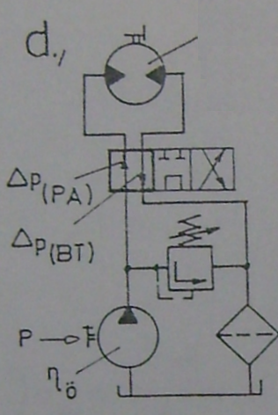$η_{\text{total} \text{motor}}=0,\text{87}$${Δp}_{\text{pump}}=? \text{bar}$$P_{\text{out}}$
$q_{v}=? \frac{{\text{dm}}^{3}}{\text{min}}$
$P=? \text{kW}$

$P_{\text{out}}=? \text{kW}$
$η_{\text{total} \text{circ}}=? \text{\%}$

