**Essay for the course**

**Dynamics of vehicle**

**Tire forces and models of vehicle**

Client: Dr. Tamas, professor at the Obuda University, Hungary

Author: Karl Schießl, Erasmus student at the Obuda University, Hungary, 6.11.2017

**Index**

1. **Introduction**
2. **Longitudinal and lateral forces**
3. **Brush model**
   1. Assumptions
   2. Pure longitudinal slip
4. **Magic formula**
5. **Magic trick**
6. **References**
7. **Introduction**

The description of tire forces is very important because they have high influence at the dynamic of a vehicle. The knowledge of size, direction and limit of the tire forces are essential and valuable for vehicle control systems like the ABS.  
There are three types of models:

* Mathematical models
* Physical models and
* a mix between both of them.

In this essay we will look at simple physical and mathematical models. In reality the models are often more complicated.

1. **Longitudinal and lateral forces**

Tire forces are generated inside the contact patch of the tire and the ground

They are a combination of two factors:

– Friction/sliding in the contact patch, and

– Elastic deformations/slipping of the tire.

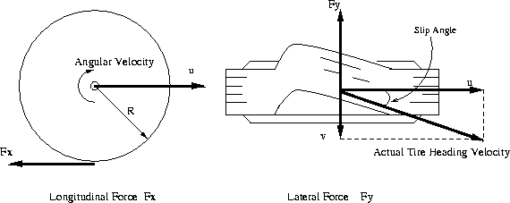

Picture 1 Basic variables of tire

The longitudinal tire force Fx is generated when breaking or driving while the lateral force Fy is generated when cornering.

The longitudinal slip of the tire is defined as a difference between the tire tangential speed and the speed of the axle relative to the road, which is represented by the following equation.

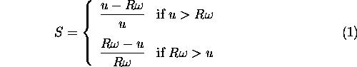

***S***: longitudinal slip; ***R***: radius of the wheel; ***ω***: angular velocity; ***u***: speed of the axle

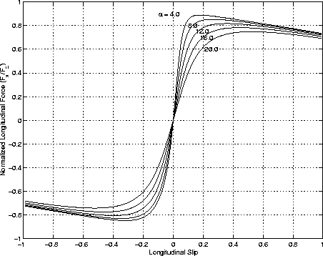

Picture 2 Longitudinal Force vs. Longitudinal Slip

When the tire generates a sideslip velocity *v*, a lateral force will develop opposing the sideslip velocity. This lateral force is a function of slip angle, where slip angle is defined as:

equation37

***v***: sideslip velocity; ***u***: speed of the axle

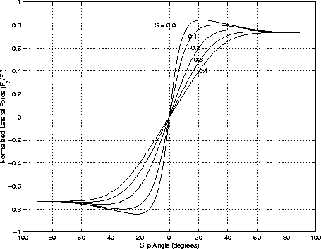

Picture 3 Lateral Force vs. Slip Angle

1. **Brush model**

The brush model is a simple longitudinal tire/road friction model, and we have to do some assumptions for the model. Also, we have to understand how the model works.

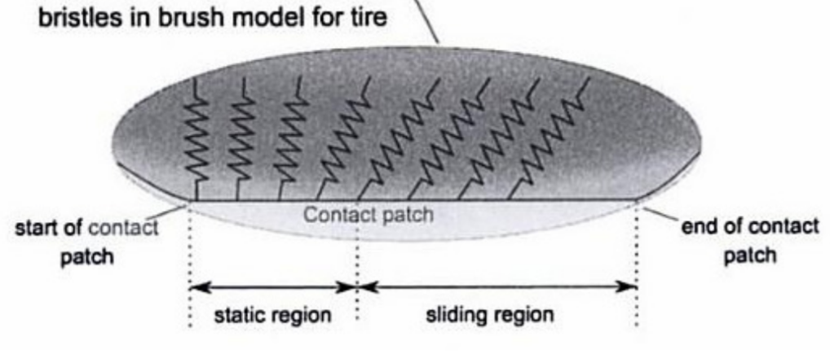

There are two regions on the contact pitch of the tire and the ground. The static region where the tire doesn´t slide and the sliding region where the tire slips over the ground. If you hold a brush and roll it on the table you can see it very well.

* 1. **Assumptions**

First of all we have to assume that the center of rotation is still the normal center of the tire. In reality this is not true!

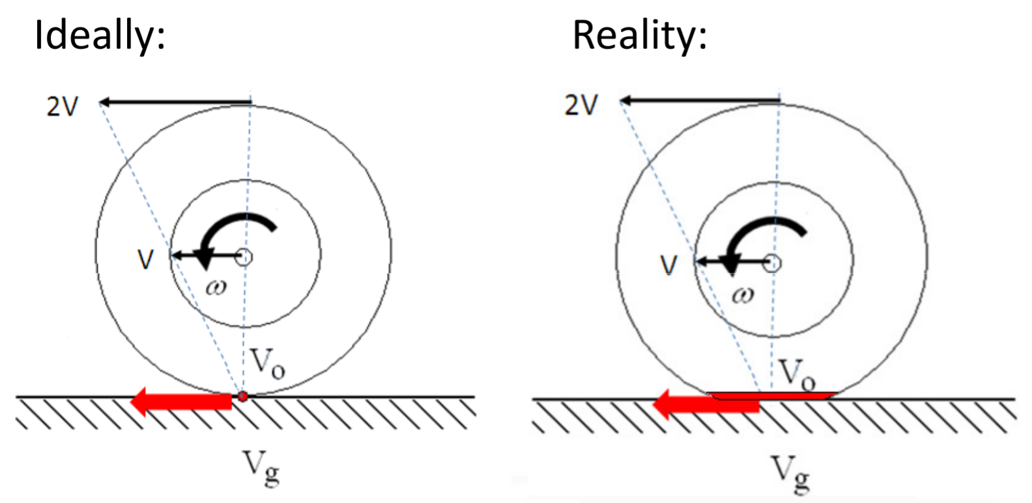

The second assumption we have to do is the effective radius.

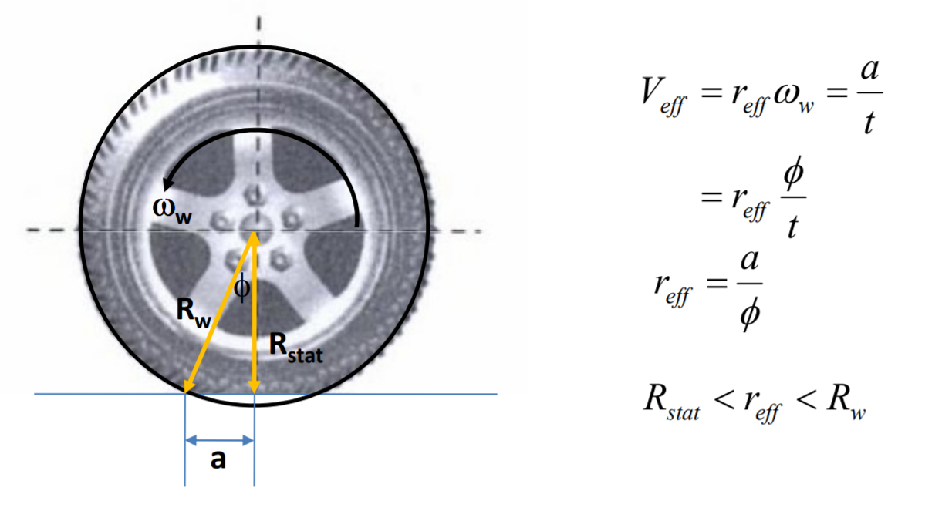

***Rw***: tire radius without stress; ***Rstat***: tire radius with stress; ***reff***: effectice tire radius;   
***ωW***: angular velocity; ***t***: time, ***a***: distance between ***Rw*** and ***Rstat***; **φ**: angle between ***Rw*** and ***Rstat***

Sometimes the effective radius is also assumed by

* 1. **Pure longitudinal slip**

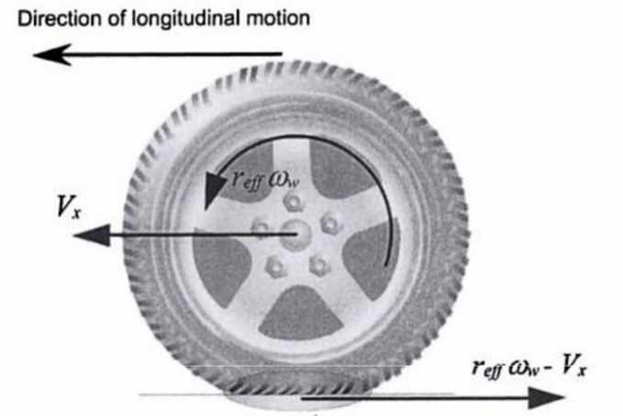

Slip Ratio: $σ_{x}=\frac{r_{eff}*ω_{W}-V_{x}}{max(r_{eff},ω_{W},V_{x})}*100\%$

***σx***: slip ratio; ***reff***: effective radius; ***ωW***: angular velocity; ***Vx***: velocity of the axel

1. **Magic formula**

The magic formula is a model which is often used in the pactice and was developed in 1993 by Pacejka and Bakker. The model is based on a pure mathematical and experiential description of the input and output of the tire-ground contact. It shows the relationship between the kinematic size of a tire to the tire forces by a combination of elemental mathematical formulas.

The general form of the magic formula is:

$$μ\left(s\right)=D*sin⁡(C*\arctan\left(B*s-E\left(B*s-\arctan\left(B*s\right)\right)\right))$$

*µ*: friction coefficient

*s*: tire slip

C: it influences the form of the curve (stretching in s direction) (form factor)

D: settles down the maximum of the friction coefficient *µmax* (maximum factor)

E: it chances the bending of the curve => it set the smax=s(*µmax*) (bending factor)

BCD=K=beginning pitch from zero point (stiffness factor)

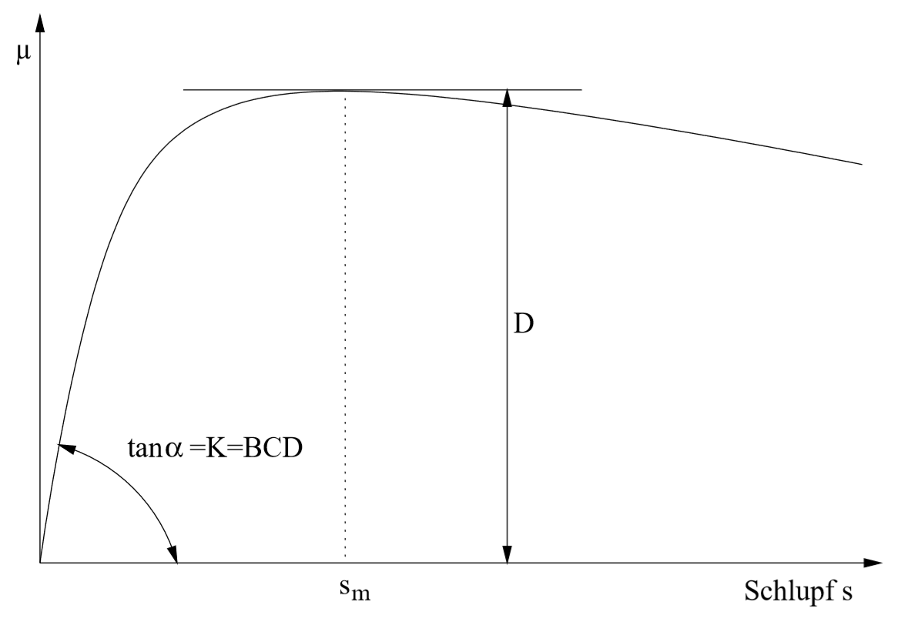

Picture 4 Meaning of the parameters

These are only interpretations of the factors because often one of them influence another one like B and C do to E:

$$E=\frac{B*s_{max}-\tan\left(\frac{π}{2C}\right)}{B*s_{max}-\arctan\left(B*s_{max}\right)}$$

The asymptotic value of *µ* towards the curve goes for is figured out with:

$$µ_{s→∞}=D*sin⁡(\frac{π}{2}*C)$$

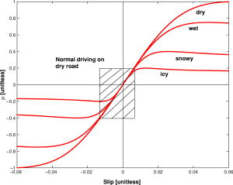

Picture 5 Magic formula with different friction factors

1. **Magic trick**

The magic formula have some disadvantages for a simulation programmer. The main problem is that the formula have complicated mathematical structure and a large number of parameters.

The „Magic Trick“ is now to get a formula with fewer parameters which is easier to code and debug. This requires much less computer effort and the difference of the value should be almost everywhere less than 10%. This will be probably sufficiently enough for a gaming simulation.

Brian Beckman found another formula which is when its plotted nearly the same like the original Magic Formula. He found that formula with an empirical method. The formula is:

$$F_{horizontal}=\frac{B*α}{1+{\left|A*α\right|}^{P}}$$

This is the generic form of the formula in which *FHorizontal* could be *Flateral* or *Flongitudinal* and α could be the slip angle or the slip ratio. So you can program the lateral or the longitudinal Magic formula. For example:

$$f(s,F_{z})=\frac{31*s*F_{z}}{(1+{\left|9,625*s\right|}^{2,375})}$$

s: longitudinal slip

FZ: vertical load

The new function is vastly easier to write down and don´t take that much computer effort. It can be used better in fast simulations and games. It is not that good that we can use it for high quality simulations!. For that we should take the original Magic Formula or other formulas and models.

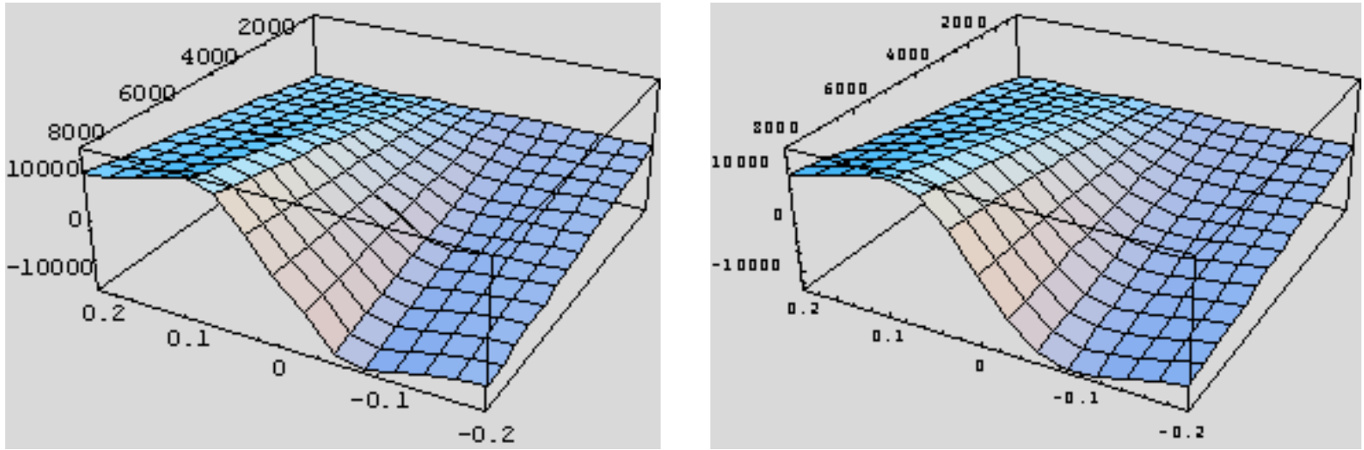

Picture 6 Left: Magic formula; Right: plotted function

1. **References**
2. Gurkan Erdogan, PhD April 27 2009, Tire Modeling 5 [lecture notes],   
   Retrieved from <http://www.menet.umn.edu/~gurkan/Tire%20Modeling%20%20Lecture.pdf>
3. Brian Beckman, PhD 2002, The Physics of Racing/ Part 29: A Magical Trick, Retrieved from http://phors.locost7.info/phors29.htm
4. Retrieved from <http://code.eng.buffalo.edu/dat/sites/tire/tire.html>
5. Stefan Kerber, Dezember 2001, Bestimmung des maximalen Kraftschlusses an mit ABZ ausgerüsteten Fahrzeugen und Fahrzeugzügen [Abschlussbericht]
6. Christopher R. Carlson & J. Christian Gerdes, Nonlinear Estimation of Longitudinal Tire Slip Under Several Driving Conditions [paper]