

Vehicle Dynamics

Neutral-, over-, and understeering conditions

Hailegiorgis Dawit Lemma

Neptun Code- LQL696

Submitted to: - Dr. Tamás Szakács

Date: - January 12, 2020

Steering system

The steering system converts the rotation of the steering wheel into a swivelling movement of the road wheels in such a way that the steering-wheel rim turns a long way to move the road wheels a short way. The system allows a driver to use only light forces to steer a heavy car.

Ackermann steering geometry is a geometric arrangement of linkages in the [steering](https://en.wikipedia.org/wiki/Steering) of a [car](https://en.wikipedia.org/wiki/Automobile) or other [vehicle](https://en.wikipedia.org/wiki/Vehicle) designed to solve the problem of wheels on the inside and outside of a turn needing to trace out [circles](https://en.wikipedia.org/wiki/Circles) of different [radii](https://en.wikipedia.org/wiki/Radius).

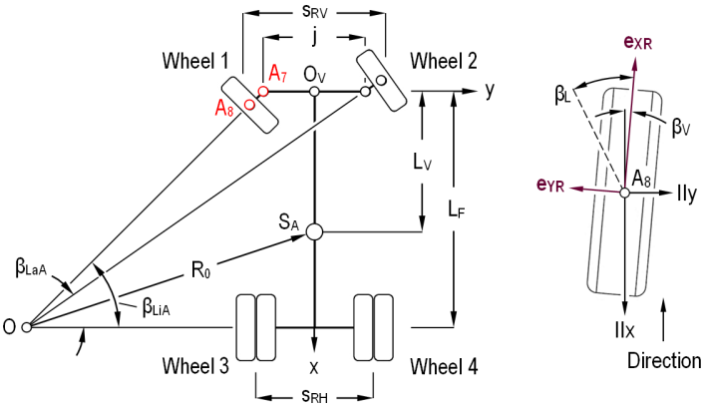

Figure 1. Ackermann steering geometry

one of the main requirements of a vehicle steering mechanism is to give to the steerable wheels a correlated *βL* such that, the intersection of the wheel axes  
should meet at the center of the bend, O. This rule which can also be seen for a two axle vehicle is known as “Ackermann Principle”. Mathematically, Ackermann Principle can be expressed as:-

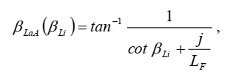

where *βLa* is the steering angle of the outer wheel and *βLaA* is the ideal turning angle which is obtained from above equation for a given steering angle *βLi* of the inner wheel.

Neutral-steering

When a vehicle turns at a rate exactly proportional to the rate at which the steering wheel is turned, it is said to have neutral steering. The characteristic of a vehicle's slip angles where both front and rear are the same. In slippery conditions, both the front and rear tires will break loose at the same time so that the vehicle slides sideways rather than the rear end swinging around (oversteer) or the front end wanting to move to the rear (understeer). A cornering condition in which the front and rear slip angles are roughly the same. Although seemingly an ideal state of balance, perfect neutral steer is not as stable as slight understeer.

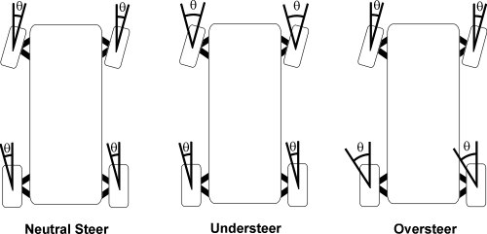

Figure 2. Neutral, Understeer and Oversteer condition

An alternative measure to understeering coefficient is the longitudinal position of the neutral steering point. The point is defined for lateral force disturbance during steady state straight-aheaddriving, as opposed to steady state cornering without lateral force disturbance. The point is where a vehicle external lateral force, such as wind or impact, can be applied on the vehicle without causing a yaw velocity, i.e. only causing lateral velocity. From this definition we can derive a formula for calculating the position of the neutral steering point,

**Mathematical Model**

Equilibrium:

0= $F_{fy}+F_{ry }+F_{e}$;

0= $F_{fy}.l_{f}+F_{ry }.l_{r}+F_{e}.l_{s}$;

Constitution:

$$F_{fy}={-C}_{f }.S_{fy}$$

$$F_{ry }={-C}_{r}.S_{ry}$$

Compatibility:

$S_{fy }=S_{ry}=\frac{Vy}{Vx}$;

Eliminate $F_{fy}$, $F_{ry }$, $S_{fy }$, $S_{ry,}$ $F_{e}$, yields;

*l*s =

Express with understeering gradient;

$ku$ = $\frac{{C_{r}.l_{r}-C}_{f }.l_{f}}{C_{f }.C_{r}.L}$

*l*s *=*

*l*s = =*;* where $ku$ = $\frac{{C_{r}.l_{r}-C}_{f }.l_{f}}{C_{f }.C_{r}.L}$

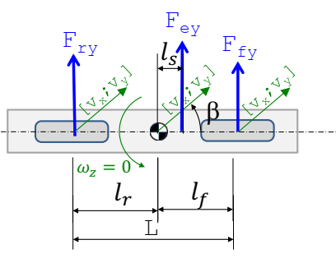

Where *l*s is neutral steering point and *K*u is understeering gradient

Under-steering

understeer is what occurs when a car steers less than the amount commanded by the driver. understeer as the condition in which you must turn the steering wheel more than expected in order to keep the car on a desired arc.

What determines how much steering input is “expected”? Different vehicles have different steering sensitivity, and the amount of steering input required to turn on a given arc will vary from car to car. But it doesn’t take long in a particular car to get used to its steering response. You quickly learn what to expect when you turn the steering wheel, and you can easily tell if it is understeering or oversteering significantly. However, a more technical definition of oversteer and understeer involves the so-called understeer gradient. The understeer gradient compares the steering input required to hold the car on a circle at increasing speed with the input required to hold the car on the same circle at very low speed. If more and more input is required as speed increases, the understeer gradient is positive, and the car is understeering. If less and less steering input is required as speed increases, the understeer gradient is negative, and the car is oversteering.

The car does not accelerate with respect to a reference frame moving with it, so in the car’s reference frame the vector sum of all the forces (including the inertial forces) has to add up to zero. Also, the vector sum of all the “moments,” or torques, around any point on the car must equal zero to keep the car from falling over or flipping end-to-end. A moment may be described as a measure of the ability of a force to produce a rotation, and unless a moment is countered by another moment, it will cause a body to rotate. There are force acting which include centrifugal force, The centrifugal force acts through the center of mass, and the friction force exerted by the pavement on the tire acts at the contact patch where the tire touches the pavement. Because the two opposing forces are not in line with each other, the wheel and tire would tend to fall over, but the rotational moment produced by these two forces is counteracted by an opposite moment exerted by the axle. However, the two forces will cause the sidewall of the tire to flex, as shown in the figure. As the tire rolls forward, the next contact patch to land on the pavement, shown as Patch A in the figure, will land on the pavement slightly to the outside of the current contact patch.

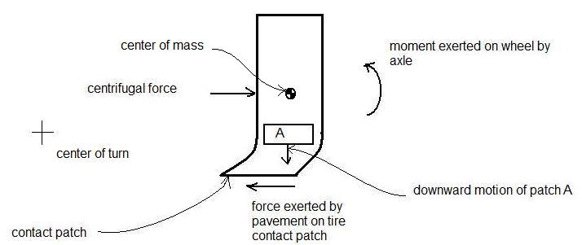

Figure 3 – Tire sidewall flexion in turn

This sideways displacement persists as the tire rolls along, producing a “slip angle” between the direction in which the tire is aimed and the direction in which it travels over the ground.

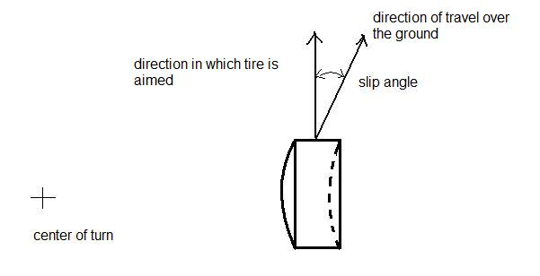

Figure 4 – Slip angle

The front and rear tires are not likely to flex equally. Figure 4 shows the usual case, in which the front slip angle is greater than the rear slip angle. This condition produces understeer. The tires are easier to see in an open-wheel race car, which my crude sketch attempts to depict.

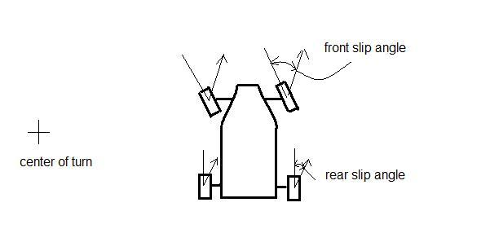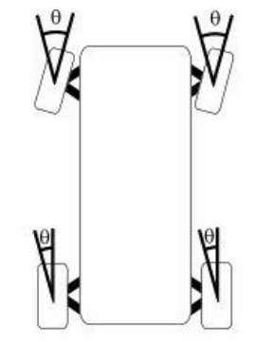

Figure 5 – Unequal slip angles producing understeer

In a turn, if the car is rear-wheel-drive, thrust from the rear wheels will cause the front tires to flex even more, because the front wheels are turned at an angle to the direction in which the thrust is applied to them. This causes the car to understeer more as thrust is increased.

Understeer skids are less common than oversteer skids. Especially in front-engined cars with a lot of forward bias in weight distribution, the available friction force is a lot higher on the front tires than on the rear tires because the vertical force *N* on the front tires is a lot higher. In this case, the friction circle is smaller for the rear tires, and it is easier to get to the edge of the friction circle by applying too much thrust. In this case, you still have traction on the front tires, but not on the rear. Then the rear wheels skid outward because of centrifugal force and because the available friction force is reduced when the tires are sliding.

Over-steering

oversteer is the condition in which you have to turn the steering wheel less than expected. Over steer is when the rear wheels are carving a larger arc than the front wheels or the intended line of the turn. Rear "slip angles" exceed those of the front tires. This is often described as a "loose" condition, as the car feels like it may swap ends, or be "twitchy." This condition can be caused by "power over steer", where you need to reduce power in order to bring the back end back into line.

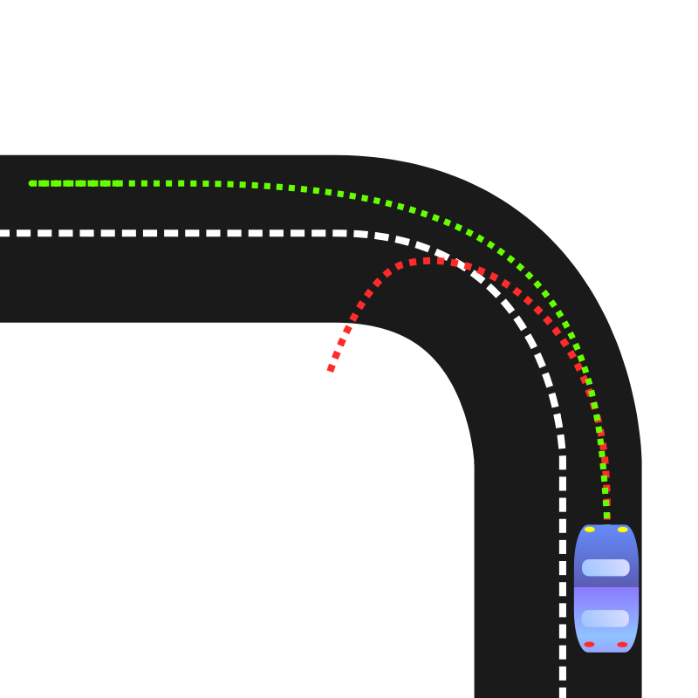

Figure 6. Oversteering

Oversteer is much less common in modern vehicles which have traction control and are more likely to be set up to understeer. Oversteer is most easily caused by too much power applied through the rear wheels, but most cars are now front-wheel drive which means the only type of oversteer there's a risk of is likely to be caused by braking or lifting off the throttle in the middle of a corner.

Having different tires can cause oversteer. For example, if the rear tires are worn more than the front tires, oversteer is more likely in wet weather because the rear tires won't displace water as effectively from the road. If the rear tires are a harder rubber compound than the front tires, the front tires will grip relatively well in relation to the rear tires. Different tread patterns can also affect overall grip.

Motorcyclists have to be more aware of oversteer as it can lead to a [high side or low side crash](https://www.drivingtests.co.nz/resources/highside-and-lowside-motorcycle-crashes-explained-video/).

Heavy vehicle drivers don't usually have enough instantly available power to spin the rear wheels and cause oversteer. However, there are scenarios where it can occur.

* If the road is very slippery, the torque of the engine can overcome the grip available from the tires.
* If there is a tail-heavy load the lateral g-forces can exceed the tires’ grip.

The proper correction for an oversteer skid is often stated thus: -Steer in the direction of the skid. If you understand what that means—steer in the direction in which the rear wheels are skidding you will react properly, but many people in my experience interpret this instruction incorrectly and steer in the direction in which the car is spinning. This makes the skid worse, and once you do that, recovery is almost impossible. I know of three ways to think about how to react that will lead to the correct response:

1) counter steer

2) look (and steer) in the direction in which you want the car to go and

3) steer in the direction opposite to the direction in which the car is spinning.

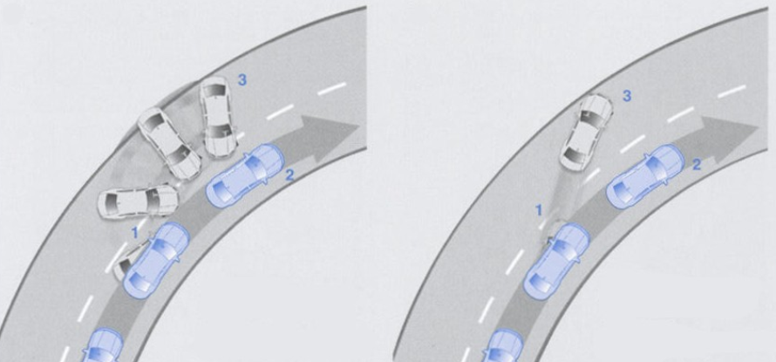

Figure 7. Oversteering and understeering