

**Óbudai University**

**Donát Bánki Faculty of Mechanical and Safety Engineering**

**1081, Budapest, Népszínház u. 8.**

**Longitudinal slip and tire forces**

1. **Members:** Juan Esteban Ordonez (BJUR9G)

Amel Mensi (PJZBM9)

Ahmad Saleem (KM9I3D)

1. **Date submitted:** Budapest, 2020/01/17.
2. **Tile:** Longitudinal slip and tire forces

Over the years, several researchers have investigated the lateral dynamics of tires to understand the influence that these dynamics have on the transient response of ground vehicles. Usually a "relaxation length" or similar metric is used to characterize a first order lag in lateral shear force buildup. Longitudinal tire dynamics have not been subject to as much attention as lateral tire dynamics. Perhaps, this is because tires are stiff in the longitudinal direction, hence traditional kinematic relationships relating wheel spin to longitudinal slip, and longitudinal slip to shear forces at the tire road interface provide an adequate model for most simulation purposes. As an overview of tire and vehicle modeling, ca for a further elaboration of the tire shear forces and moments are generated under time varying lateral and longitudinal slip. Motivated by a desire for a seamless transition between high and low speeds for vehicle simulations using semiempirical tire models, presented a longitudinal analogy to the lateral relaxation length. This essay will briefly represent the model of the before mentioned forces. It further on will provide an analysis of the consequences of the first order lag in longitudinal slip. Initially, coupled differential equations for wheel spin and longitudinal slip are linearized by assuming constant forward speed and a linear relationship between longitudinal force and longitudinal slip. The final section of the report shows that the linearization of the coupled wheel spin/longitudinal slip equations, applied on a time-step-wide basis, makes possible the integration of the very stiff coupled differential equations of wheel spin and longitudinal slip at routine vehicle simulation rates. This is important in view of the need for driving simulators to run in real-time. The basic aim is plantain a basic but valid equation model, in order to be demonstrated either through simulation or simple tests. [1]

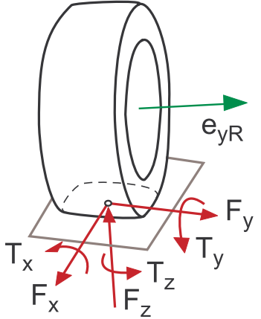

Figure 1. Basic tire forces and torques applied on a wheel.

* 1. **Tire Model in Driving Simulator**

Forces initially are generated by the engine, where afterwards is transmitted to the traction wheels through the transmission and traction mechanisms. A linear analysis of a tire model usually considers fixed side tire’s force coefficients at small force output. The linear tire model does not consider longitudinal forces due to the complexity of the interactions amongst the lateral and the longitudinal tire forces. Therefore, the linear tire model is suitable for analyzing a stable vehicle behavior considering the assumption of a negligible steering and acceleration. Mainly, the AHS (Automated Highway System) utilize a linear tire model due to its simplicity. For modelling purposes, is very important to describe an accurate behavior of a vehicle under any driving scenario including extreme driving conditions which may require severe handling, braking, acceleration, and even some other driving related operations. Thus, to simulate the complete vehicle operational range, it is important to properly model all the tire forces within the interactions all longitudinal and lateral forces from small levels through saturation. The tire model used in the driving simulator is based on a paper from U.S Department of Transportation [2]. Through the following sections, the tire model by physical and analytical way is presented with the very basic tire variables. In addition, through the obtained plots will provided not only a validation of this tire model, but a brief insight into tire effects on vehicle response and stability, as well.

* 1. **Slip Angle and Longitudinal Slip**

The longitudinal and lateral forces generated by a tire are a function of the so-called *slip angle* and longitudinal slip of the tire relative to the road.

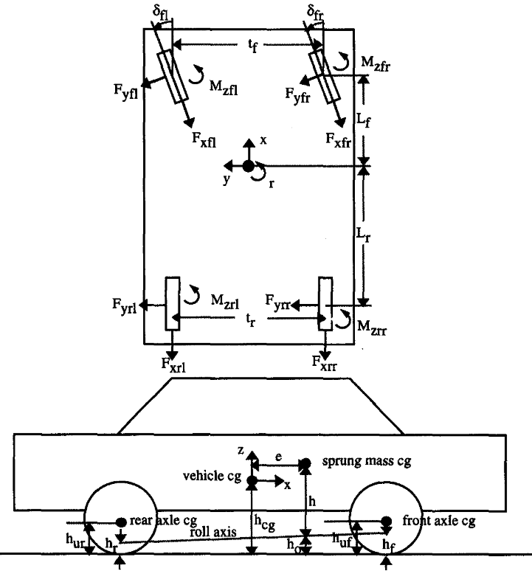

Figure 2. Sign convention for an eight-degree of freedom vehicle.

The longitudinal slip of the tire is defined as a difference between the tire tangential speed and the speed of the axle relative to the road, which is represented by the following equation.

$$S=\left\{\begin{aligned}\frac{u-Rω}{u} if u>Rω \\ \frac{Rω-u}{Rω} if Rω>u\end{aligned}\right.$$

Equation 1. Longitudinal slip of the tire.

  where *S* is the longitudinal slip, *R* is the radius of the wheel $ω$,  is the angular velocity, and $u$  is the speed of the axle illustrated in Figure 2. The value of the longitudinal slip is limited such that $\left|S\right|≤1$  . For braking, axle speed is used in the denominator so that longitudinal slip is 1 when $ω$  is zero. Slip has the opposite sign when tracking force is generated.  
If the tire performs a sideslip velocity quoted by *v* in Figure 2, a strong lateral force will develop opposing the sideslip velocity. This brand-new lateral force is a function of the slip angle, slip angle is defined as:

$$α=\tan^{-1}{\frac{v}{u}}$$

Equation 2. Slip angle in function of slip angle.

where *v* is the sideslip velocity, and *u* is the speed of the axle. The value of the slip angle is limited such that $\left|α\right|≤90°$   .

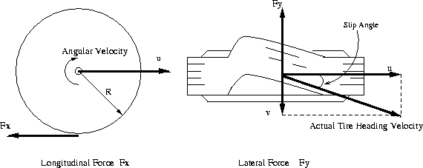

Figure 3. Basic variables of a tire

* 1. **Simplified Tire Model Equations**

The previous theoretical developments lead to a complex, highly non-linear composite force as a function of composite slip. It is convenient to define a saturation function, $f(σ)$  , to obtain a composite force with any normal load and coefficient of friction values such that:

$$f\left(σ\right)=\frac{F_{c}}{μ F_{z}}$$

Equation 3. Compose force with normal load.

Simplifying the formulas for our driving simulator, the complex polynomial expression can be replaced as the complex saturation function with all the considerations in previous section within the agreeable error ranges. The polynomial expression of the saturation function is presented by:

$$f\left(σ\right)=\frac{F_{c}}{μ F_{z}}=\frac{C_{1}σ^{3}+C_{2}σ^{2}+(4/π)σ}{C_{1}σ^{3}+C_{3}σ^{2}+C_{4}σ+1}$$

Equation 4. Equation cleaned including diverse required constants.

 where $C_{1}$ , $C_{2}$, $C_{3}$ and $C_{4}$  are parameters fixed to the specific tires. Table 1 summarizes the tire parameters of 3 different type of tires. RWD bias ply tire model is used for all the driving simulation presented in this paper. The calculation of the composite slip shown in Equation 7 should be modified because the tire contact patch length varies depending on the normal load. The tire contact patch length is calculated using following two equations.

$$a_{po}=\frac{0.0768\sqrt{F_{ZT}F_{c}}}{T_{ω}(T_{φ}+5)}$$

Equation 5.

$$a_{p}=a_{po}\left(1-K_{a}\frac{F_{x}}{F_{z}}\right)$$

Equation 6.

where $a_{p}$  is the tire contact patch, $T_{ω}$  is a tread width, and $T_{φ}$  is the tire pressure. The values of $F_{ZT}$  and $K_{a}$  are also shown in Table 1. The lateral and longitudinal stiffness coefficients are a function of tire contact patch length and normal load of the tire as expressed as follows.

$$K_{s}=\frac{2}{a_{po}^{2}}\left(A_{0}+F_{z}A_{1}-\frac{A_{1}}{A_{2}}F_{z}^{2}\right)$$

Equation 7.

$$K_{c}=\frac{2}{a_{po}^{2}}F_{z}\left(CS/FZ\right)$$

Equation 8.

where the values of $A_{0}$ , $A_{1}$  , $A_{2}$  , and $CS/FZ$  are given in Table 1. Then the composite slip calculation becomes

$$σ=\frac{πa_{po}^{2}}{8μ_{o}F_{z}}\sqrt{K_{s}^{2}\tan^{2}{α}+K_{c}^{2}{\left(\frac{s}{1-s}\right)}^{2}}$$

Equation 9.

$μ_{o}$ is a nominal coefficient of friction and has a value of 0.85 for normal road conditions, 0.3 for wet road conditions, and 0.1 for icy road conditions.

|  |  |  |  |
| --- | --- | --- | --- |
| Parameter | RWD radial | RWD bias ply | FWD radial |
| *Tire Designation* | *155 S R13* | *P155/80 R13* | *P185/70 R13* |
| $$T_{ω}$$ | 6 | 6 | 7.3 |
| $$T_{φ}$$ | 24 | 24 | 24 |
| $$F_{ZT}$$ | 810 | 900 | 980 |
| $$C_{1}$$ | 1.0 | 0.535 | 1.0 |
| $$C_{2}$$ | 0.34 | 1.05 | 0.34 |
| $$C_{3}$$ | 0.57 | 1.15 | 0.57 |
| $$C_{4}$$ | 0.32 | 0.8 | 0.32 |
| $$A_{0}$$ | 914.02 | 1817 | 1068 |
| $$A_{1}$$ | 12.9 | 7.48 | 11.3 |
| $$A_{2}$$ | 2028.24 | 2455 | 2442.73 |
| $$A_{3}$$ | 1.19 | 1.857 | 0.31 |
| $$A_{4}$$ | -1019.2 | 3643 | -1877 |
| $$K_{a}$$ | 0.05 | 0.2 | 0.05 |
| $$K_{1}$$ | -0.0000122 | -0.000257 | 0.000008 |
| $$CS/FZ$$ | 18.7 | 15.22 | 17.91 |
| $$μ_{o}$$ | 0.85 | 0.85 | 0.85 |

Table 1. Diverse parameters utilized in the Modeled Equations. [3]  
.

Figure 4. Procedures of tire force calculations.

Upon the polynomial was done, the saturation function and lateral and longitudinal stiffness, the normalized lateral and longitudinal forces are derived by resolving the composite force into the side slip angle and longitudinal slip ratio components.

$$\frac{F_{y}}{{μF}_{z}}=\frac{f\left(σ\right) K_{s} \tan{α}}{\sqrt{K_{s}^{2}\tan^{2}{α}+K_{c}^{'2}S^{2}}8}+Y_{γ}γ$$

Equation 10.

$$\frac{F_{y}}{{μF}_{z}}=\frac{f\left(σ\right) K_{s} \tan{α}}{\sqrt{K_{s}^{2}\tan^{2}{α}+K_{c}^{'2}S^{2}}}$$

Equation 11.

The lateral force has an additional components due to the tire camber angle, $γ$ , which is modeled as a linear effect. Under significant maneuvering conditions with large lateral and longitudinal slip, the force converges to a common sliding friction value. In order to meet this criteria, the longitudinal stiffness coefficient is modified at high slips to transition to lateral stiffness coefficient as well as the coefficient of friction defined by the parameter $K_{μ}$  .

$$K_{c}^{'}=K_{c}+(K_{s}-K_{c})\sqrt{\sin^{2}{α}+S^{2}\cos^{2}{α}}$$

Equation 12.

$$μ=μ_{o }\left[1-K_{μ}\sqrt{\sin^{2}{α}+S^{2}\cos^{2}{α}}\right]$$

Equation 13.

The constant value of 0.124 was used for $K_{μ}$  in the tire model. The summarized procedures to calculate the longitudinal and lateral forces are shown in Figure 4. As a result, in this section, the longitudinal and lateral tire force plots are included in Figure 5 through Figure 8 for normal driving conditions of $μ=0.85$  .

The incoming graphs were deployed during simulation within an embedded software, as a result it will depicted as follows.

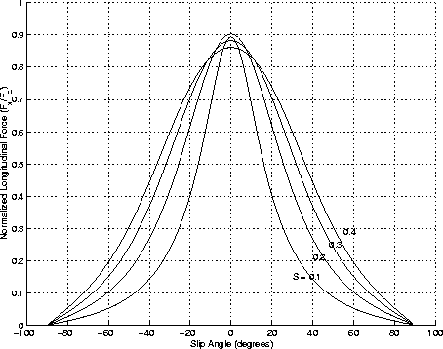

Figure 5. Normalized Longitudinal Force vs. Slip Angle

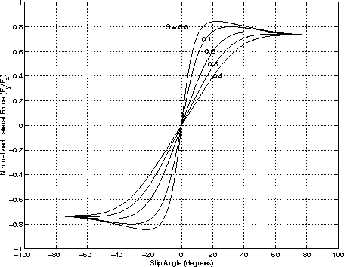

Figure 6.Normalized Lateral Force vs. Slip Angle

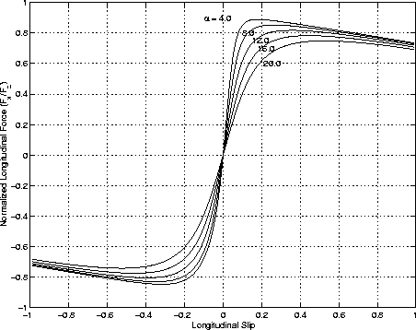

Figure 7. Normalized Longitudinal Force vs. Longitudinal Slip

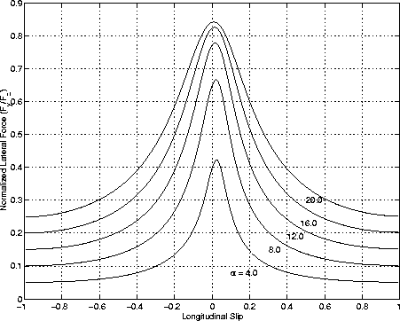

Figure 8. Normalized Lateral Force vs. longitudinal Slip

Is important to highlight that all the simulated plots can be attempted within any other mathematical software (i.e. Matlab)

The traditional formulation of the relationship between wheel spin and longitudinal slip is a kinematic relationship. This paper presents an analysis of the consequences of relating wheel spin and longitudinal slip with a first order lag. Local linearization indicates that an important implication of this relationship is the potential for complex roots at low vehicle speeds. These roots indicate that there is the potential for oscillations in response to brake or drive torque applications and resonant response resulting from the action of traction' control systems (TCS) and anti-lock braking systems (ABS). The differential equations underpinning the wheel spin/longitudinal slip model

are stiff compared to the demands of traditional vehicle simulation. The local linearization also provides the basis for integrating the model at traditional vehicle simulation rates. Examples indicate the effectiveness of this technique. [1]

With minor modification, the $μ$ estimation procedure can be used to determine when a vehicle is on a split - $μ$ surface, if the eight-degree- of-freedom vehicle model and estimation of individual longitudinal forces are retained. These vari- ations, along with additional robustness studies, experimental verification of road-friction identification on other road surfaces, and use of the algorithm in feedback control systems are the subject of future research. [4]

1. **Bibliography**

|  |  |
| --- | --- |
| [1] | J. B. C. Clover, Longitudinal tire dynamics, vol. 29, Iowa: Centre for Emerging Manufacturing Technology, 1998, pp. 231-259. |
| [2] | U. o. Buffalo, "Control, Dynamics and Estimation Laboratory," 2018. [Online]. Available: http://code.eng.buffalo.edu/dat/sites/tire/tire.html. [Accessed 2018]. |
| [3] | Szostak, H.T., Allen, W.R., and Rosenthal, T.J, "An Interactive Model for Driver/Vehicle Simulation," *Analytical Modeling of Driver Response in Crash Avoidance Maneuvering Volume II,* April 1998. |
| [4] | L. R. Ray, "Nonlinear Tire Force Estimation and Road Friction Identification: Simulation and Experiments," *Automatica,* vol. 33, no. 10, pp. 1819-1833, 1997. |
| [5] | G. Rill, "III European Conference on Computational Mechanics," *III European Conference on Computational Mechanics,* no. May, 2006. |
| [6] | S. Miller, B. Youngber. A, Millie et al., "Calculating longitudinal wheel slip and tire parameters using GPS velocity," *Proceedings of the American Control Conference,* vol. 3, pp. 1800-1805, 2001. |