**Name:** Matheus Borghi Ricardo de Oliveira **Neptun Code**: OWMQO2

**Ackermann Condition of Turning: Special Cases**

1. **Introduction**

Steering is a term applied to the various components, elements, linkages, etc. which allows the vehicle to turn and follow the desired course. The most conventional, and the one studied is this paper, is a steering arrangement to turn the front wheels of a vehicle, using a hand-operated steering wheel in front of the driver, turning racks, pinions and joints that allow it to deviate from a straight line (1).

One particular steering geometry, called Ackerman Geometry, allows the outer front wheel of a vehicle to cover a larger radius than the internal front wheel. As a result, both wheels will face a similar curve point and both front wheels will follow individual radius paths without skidding or scrubbing as the vehicle turns in a curve, as shown in Figure 1. (2)

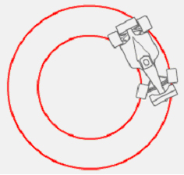

Figure 1: Ackermann condition pathing in a circle.

In mathematical terms, Ackermann wheel angles can be calculated by a geometric analysis of the vehicle, visible in Figure 2. These angles are separated in a relative steering angle of the inner wheel ($δ_{i}$) and a relative steering angle of the outer wheel ($δ_{o}$). The equation parameters also involve the track width ($L$) (lateral wheel separation), the wheelbase ($c+b$), which is the longitudinal wheel separation and the distance $r$ between the instantaneous center of curvature (ICC) and the center of the vehicle. An expression for the angles is shown in equations 1 and 2, below.

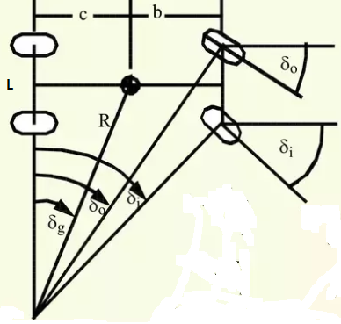

Figure 2: Ackermann angles geometry in a curve.

$$\begin{aligned}arctg δ_{i}= \frac{c+b}{r-\frac{L}{2}} \#\left(1\right)\end{aligned}$$

$$\begin{aligned}arctg δ_{o}= \frac{c+b}{r+\frac{L}{2}} \#\left(2\right)\end{aligned}$$

Despite being one of the most fundamental parameters in motion of vehicle dynamics, a perfect Ackermann Geometry can be quite challenging to achieve in an ordinary vehicle. While other parameters such as toe and camber angles are easily accessible by changing tires, Ackermann’s would require changes in car geometries, such as lengthening and shortening of steering ratios, connection points in wheel hub and steering arm and of course, wheel angles relative to the steering linkages (3).

Additionally, Ackermann’ Geometry is commonly measured in percentage, where a classic Ackermann is measured as “100 % Ackermann” (inner wheel turning more than the outer wheel), a “0% Ackermann” has wheels parallel at any steering angle, and lastly, an angle smaller than 0% is called “Inverse Ackermann” (“Anti-Ackermann”, “Reverse Ackermann” are also used) (4). Furthermore, a “negative Ackermann” corresponds to a decreasing Ackermann percentage, whereas a “positive Ackermann” to an increasing Ackermann percentage. Figure 3 shows these three types of geometries.

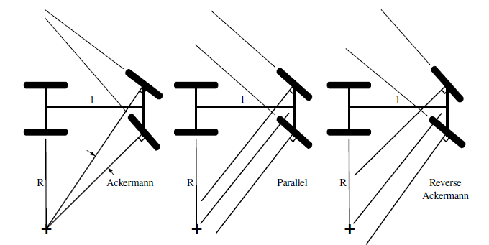

Figure 3: Different sets of Ackermann Geometry.

1. **Special Cases of Ackermann and their characteristics**
   1. *Ackermann geometry (Classic)*

This geometry is common only to a select number of existing vehicles. This is due to the increasing speed vehicles encounter when in a curve track: the cornering speed increases, and the wheels of the car will adopt slip angles, making Ackermann geometry effects obsolete. Slip angles can be understood in a simple way as the “original pathing that the wheels are going in a curve versus the way they are pointing on that same curve”. Therefore, only slower vehicles that require restricted turning cycles will be the ones to use this type of geometry, differently from modern vehicles, which will use a small amount of Ackermann compensation.

According to Pat Clarke (2004), it is found that this type of configuration can be used in FSAE cars (Formula Society of Automotive Engineers), due to their low speed and most of the tracks being formed with tight corners (5).

In a study carried out by Farrington (2011) (6), the amount of Ackermann employed in his object of study, a FSAE vehicle, was calculated through an iterative process altering the Ackermann percentage employed and the length of the steering arm, in a simulation run by *SolidWorks*. It should be said that other parameters in the vehicle were suited to apply this geometry condition, such as positioning of the pinion and rack. In the study’s results, an Ackermann of 125% is chosen, leading to an inside wheel steer and outside wheel steer of 38.29° and 25.893° respectively, and a steering ratio of 4.21:1. These were the best results considering track and corners specifications.

These results can be shown in Table 1.

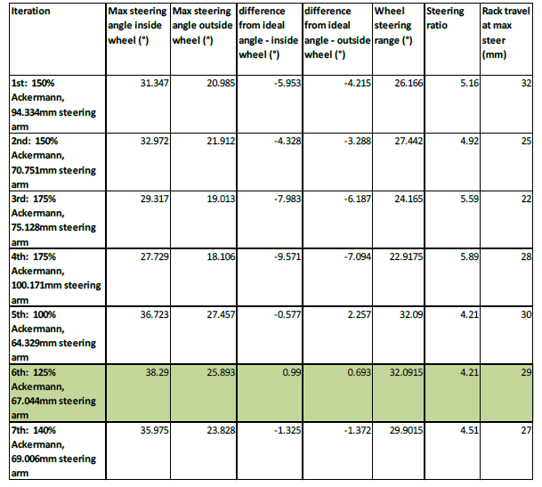

Table 1: Ackermann iteration in a FSAE vehicle.

Although it seems a good solution for these types of vehicles, it should be mentioned that the classic Ackermann Geometry causes some hurtful impact on tire wear. Besides, the formulas used to calculate this geometry does not involve tire slips angles and tire deformation on the track (7).

* 1. *Parallel Steering*

As seen in Figure 3, parallel steering is a geometry where both the wheels will turn by the same amount with the same input steering angle. In a deeper analysis, parallel steering will act as a toe-in wheel configuration in high-speed steering, and as a toe-out wheel configuration in a low-speed steering. This occurs because of the interaction between the tires and the track, causing a more evident slip angles in higher speeds, due to the centrifugal force (as a lateral force) applied to the outside part of the vehicle (8). Parallel steering is often common in race cars as well. Although it leaves out complex geometric changes in the structure of the vehicle, it will cause adverse effects when turning, such as the Toe configuration, depending on the speed of the steering. This configuration will also cause some tire wear, such as scrubbing, especially on curves.

Toe configurations can be understood as the direction the wheels are present to follow: while “in” will assure more car stability, “out” will assure more turn capability, although it will make the vehicle harder to control. The configurations of toe wheels can be shown in Figure 4.

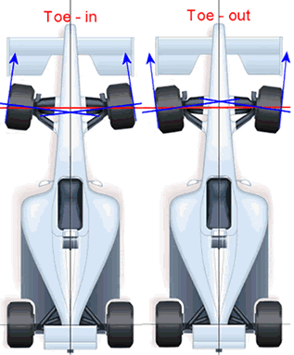

Figure 4: Toe-in and Toe-out wheel configurations.

Parallel steering Toe effects should not be mistaken with Static Toe configurations. The latter can be achieved by angling the front wheels, inside or outside the main vehicle frame. Although Static Toe configurations achieve the same desired effects as Ackermann (Toe Out) and Anti-Ackermann (Toe In), they cause serious adverse effects (instability and late steering response) when the vehicle is not making a turn or corner. Moreover, Toe configurations poorly adjusted, that means an adjustment outside the manufacturer’s specifications, can cause bad performance on wet tracks, due to a loss of grip between the tire and the road (9).

* 1. *Anti – Ackermann*

As the name suggests, Anti-Ackermann is the opposite of the Ackermann classic geometry. In this type of wheel configuration, the outer wheel angle is greater than the inner wheel angle.

This type of geometry has lots of benefits to Race cars, due to the high-speed they are subjected in racetracks. These types of vehicles are often operated at high lateral accelerations and therefore all tires operate at significant slip angles. Related to that, the loads on the curve inner wheels are much less than the curve outer wheels due to the lateral load transfer, caused by the centrifugal force. Tires with lower low loads require less slip angle to reach the peak of the cornering force. This is shown in Figure 5 – it is plausible to consider the red line as the outer wheel while the green line as the inner wheel (10).

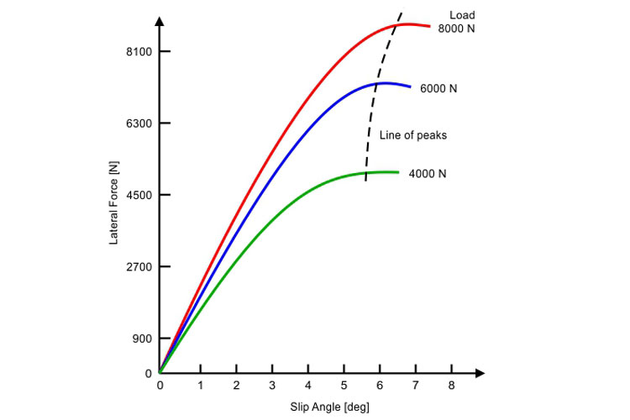

Figure 5: Slip angle interaction with lateral force on a curve.

If a low speed steering geometry was used in a situation where high-speed cornering is demanded, the inner tire would be dragged along at much higher slip angles than needed, resulting in rises of tire temperature and slowing down the car due to the slip angle induced drag. In other words, the theoretical Ackermann geometry cannot be used to satisfy the design steering system, and a new target angle relationship needs to be defined, that being the Anti-Ackermann geometry (11).

Anti-Ackermann may sometime be referred as Dynamic-Toe-In. Dynamic-Toe alludes to the change in steer-angle of one front-wheel, relative to the other front-wheel, as the steering is turned away from straight-ahead. At full-lock, this angle difference between the two front-wheel angles can reach up to 10 degrees. Figure 6 shows a clear view of an Anti-Ackermann geometry being used in a Formula 1 car.

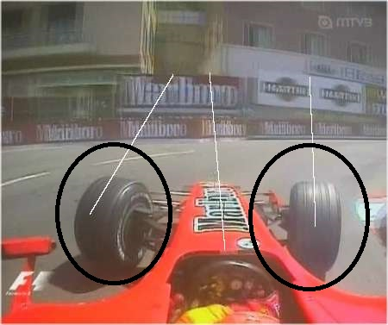

Figure 6: Anti-Ackermann being used in Formula 1. Notice how the outer wheel is much angled than the inner wheel.

The problem with Anti-Ackermann is the usage in sharp corners. As said previously, large slip-angles are not desirable because they generate drag, and while sideways might look fast, it’s not the quickest way through a corner. In a sharp corner, the wheels are forced to run at a large toe-in geometry (inner wheel more angled than the outer wheel), and the outer wheel will be close to, or beyond it’s slip-angled peak. As a result, it will become reluctant to respond to any steering inputs from the driver, and the inner wheel, as a matter of fact, be trying to push the nose of the car out of the corner (12).

1. **Conclusion**

In conclusion, designing a car with a specific Ackermann geometry is quite challenging and unique to certain optimizations. All the possible geometries explored bring with themselves some advantages to some situations and disadvantages to others. That being said, Ackermann geometry should not be exclusive to a type of vehicle, but to a design parameter to enhance vehicle performance in a specific type of situation, whether it demands high speed steering or low speed steering and considerable corner angles or swift turns on the track.

It was also shown that Ackermann geometries can be used together with other design specifications on tires and suspensions, such as camber, toe and steering angles, and not as an isolated parameter. United with these characteristics, the motion dynamics of the vehicle will certainly be rearranged and it is a open field for future research and studies.

1. **References**
2. Murphy, Tom; Corbett, Brian (2005-03-01). "Quadrasteer Off Course". Wards Auto World. Archived from the original on 2011-03-23. Retrieved 2010-06-11.
3. Erasmus Darwin's Improved Design for Steering Carriages by Desmond King-Hele , 2002, The Royal Society, London. Accessed April 2008.
4. Norris, William (1906). "Steering". Modern Steam Road Wagons. Longmans. pp. 63–67.
5. William F. Milliken and Douglas L. Milliken, 1995, “Race Car Vehicle Dynamics”, Society of Automotive Engineers, Inc.
6. Pat Clarke 2005, FormulaSAE-ANewsletter, Volume 4, Issue 1, University of New South Wales Canberra, viewed 7 July 2011.
7. Jock Allen Farrington, Redesign of an FSAE Race Car’s Steering and Suspension System, October, 2011.
8. Wm. C. Mitchell, Allan Staniforth, Ian Scott. Analysis of Ackermann Steering Geometry, Motorsports Engineering Conference & Exhibition Dearborn, Michigan, December 5-7, 2006.
9. Smith, C. (1978), Tune to Win: The Art and Science of Race Car Development and Tuning, Aero Publishers, Inc. 329 West Aviation Road, Fallbrook, CA 29028.
10. Gillespie, Thomas D., Fundamentals of Vehicle Dynamics. Society of Automotive Engineers, Inc., Pennsylvania, 1992.
11. Adam Theander, Design of a Suspension for a Formula Student Race Car, TRITA-AVE-2004-26 ISSN 1651-7660.
12. Yukio Sada (Japan). Automotive Design and Manufacturing Guide [M]. Beijing: Mechanical Industry Publishing, 2011.
13. Thompson, Dale. Ackermann? Anti-Ackermann? Or Parallel Steering? Rep. Racing Car Technology, n.d. Web. 22 Sept. 2016.